Google; iConnect MWCC Login Should come up with the login portal website for my school, Mount Wachusett Community College
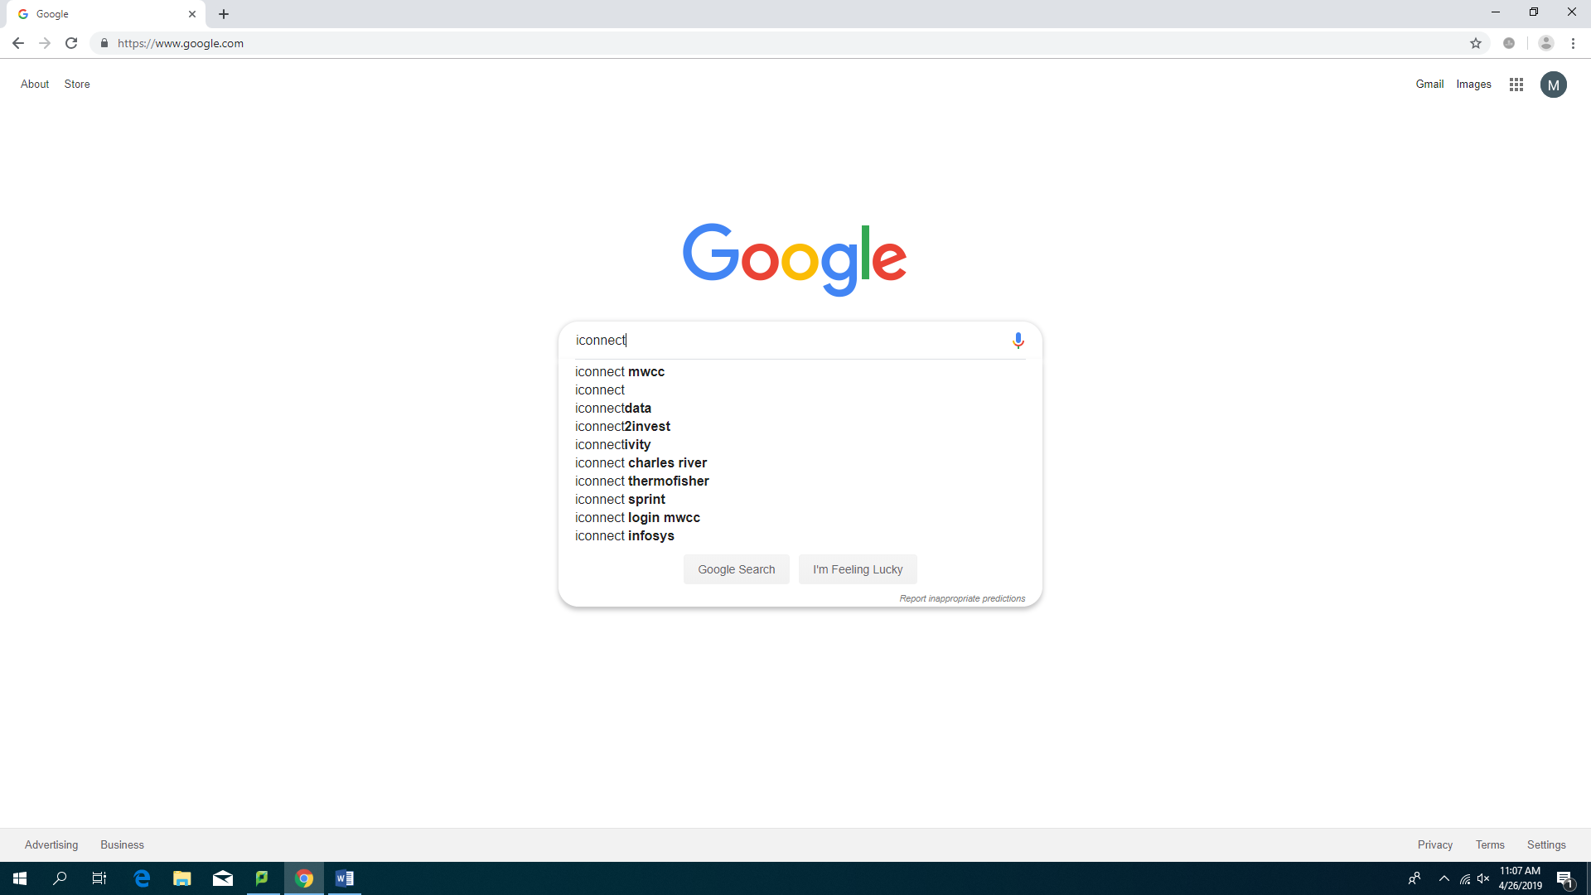

For my search it came up as the first thing
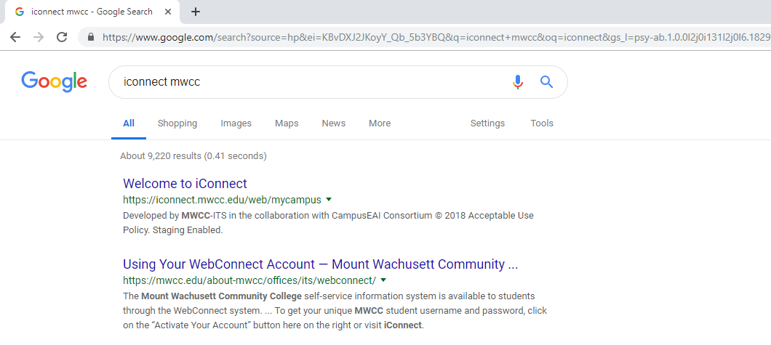

This is the login page:
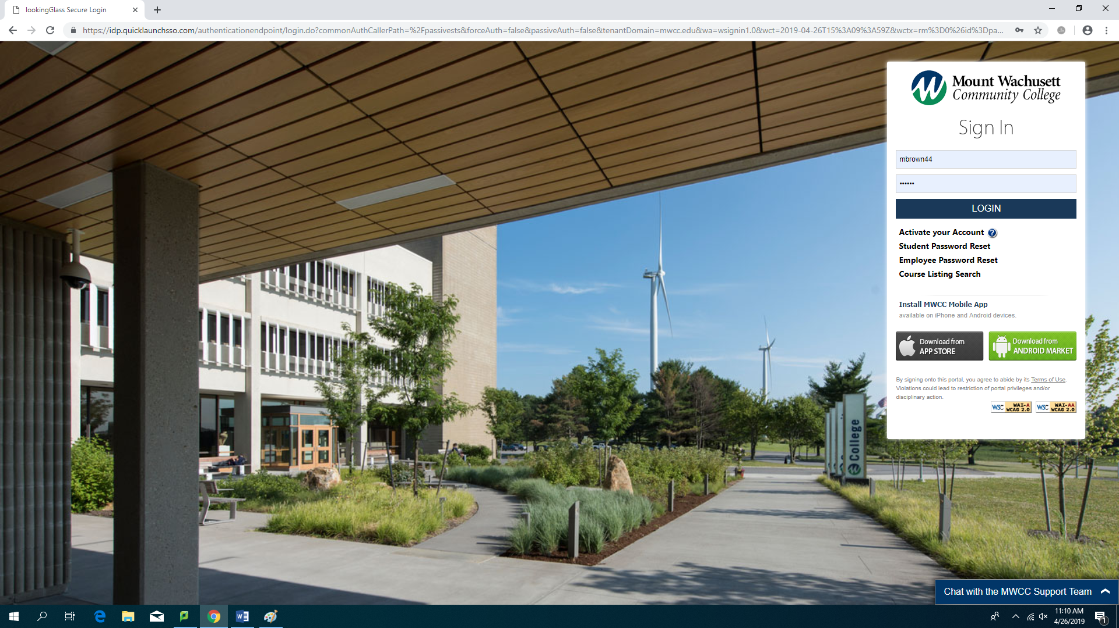
My login information is;
Username: Mbrown44
PW: KJL9HF (case sensitive)
This is the home page… Click on the icon under MY APPS that you can see in this image that says “Blackboard”
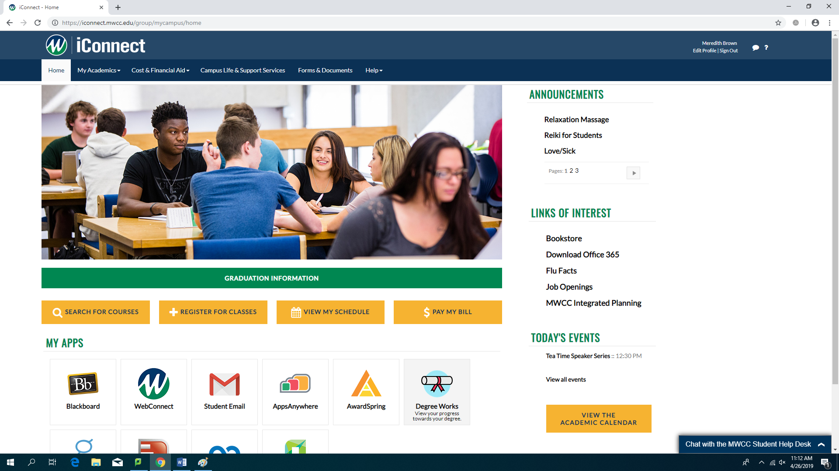
This is the home page for Blackboard… un the center of the page under my courses click on the course labeled “201901-MGT210-WEB”
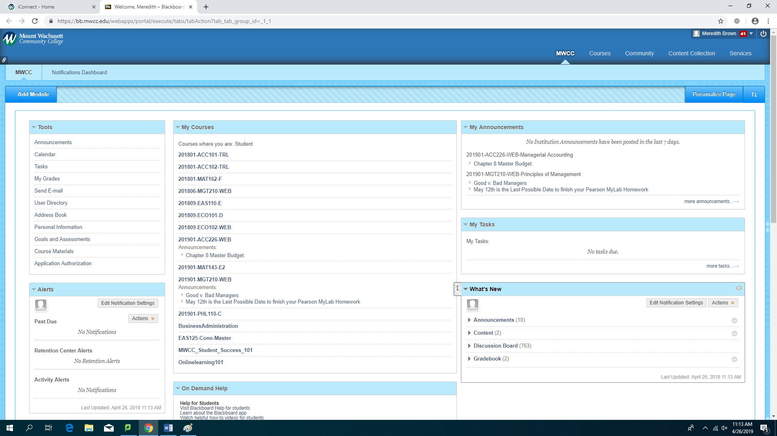
Up to this point these steps have probably looked familiar in using the Accounting course portal.
This is the home page for my Principles of Management Course. On the left you’ll see the green menu and at the bottom there is a link to “MyLab Management Web”.
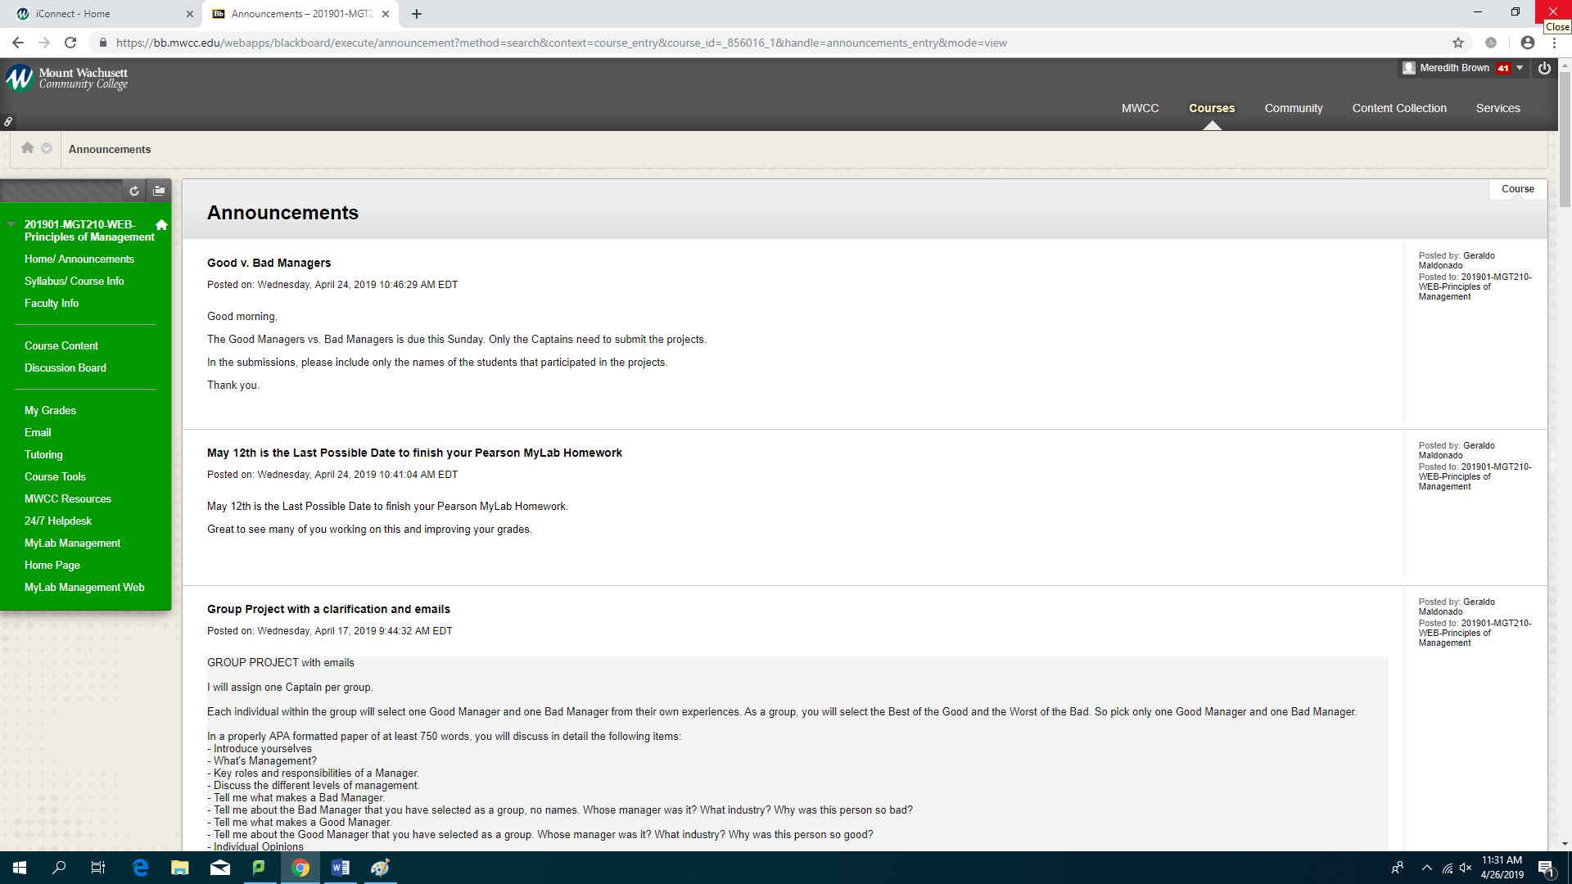
Click the only link on the page “MyLab Management Student Resources”
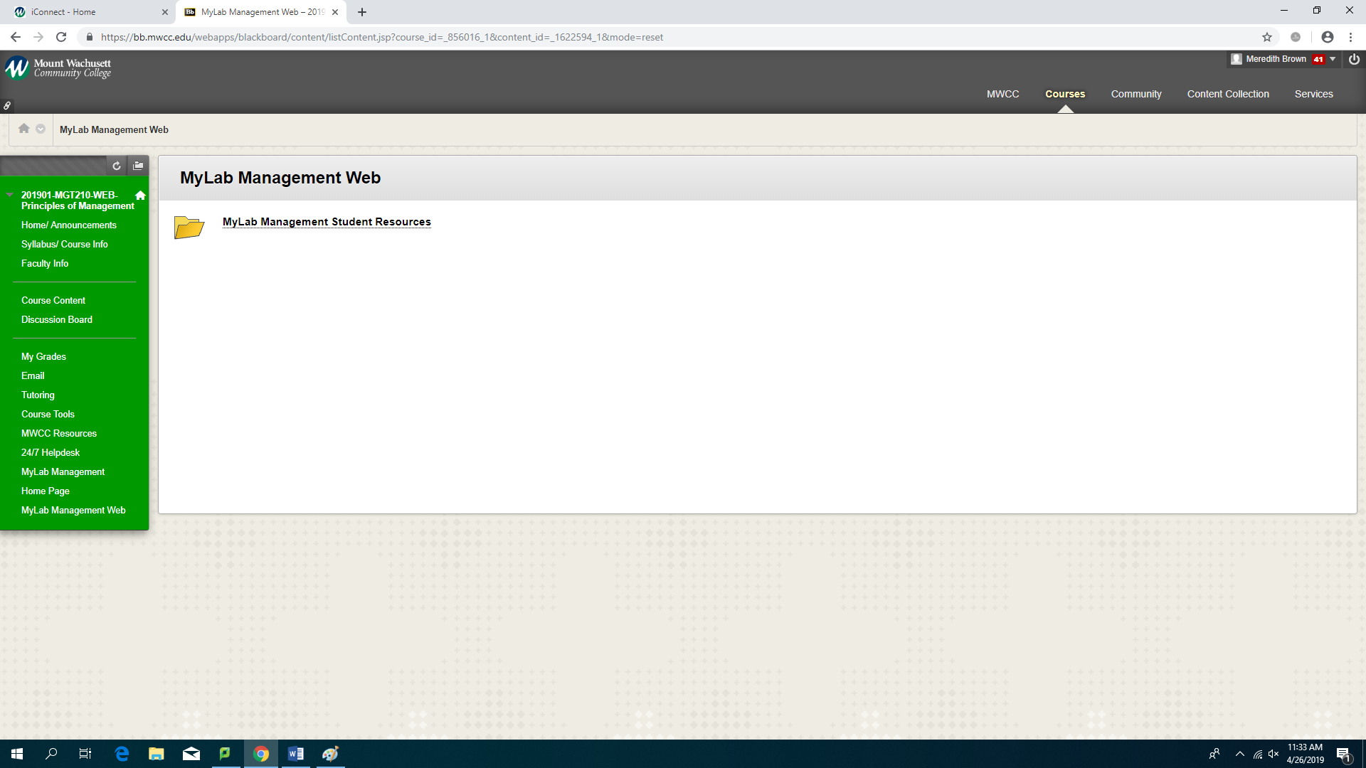
Then in this folder link click “all assignments”
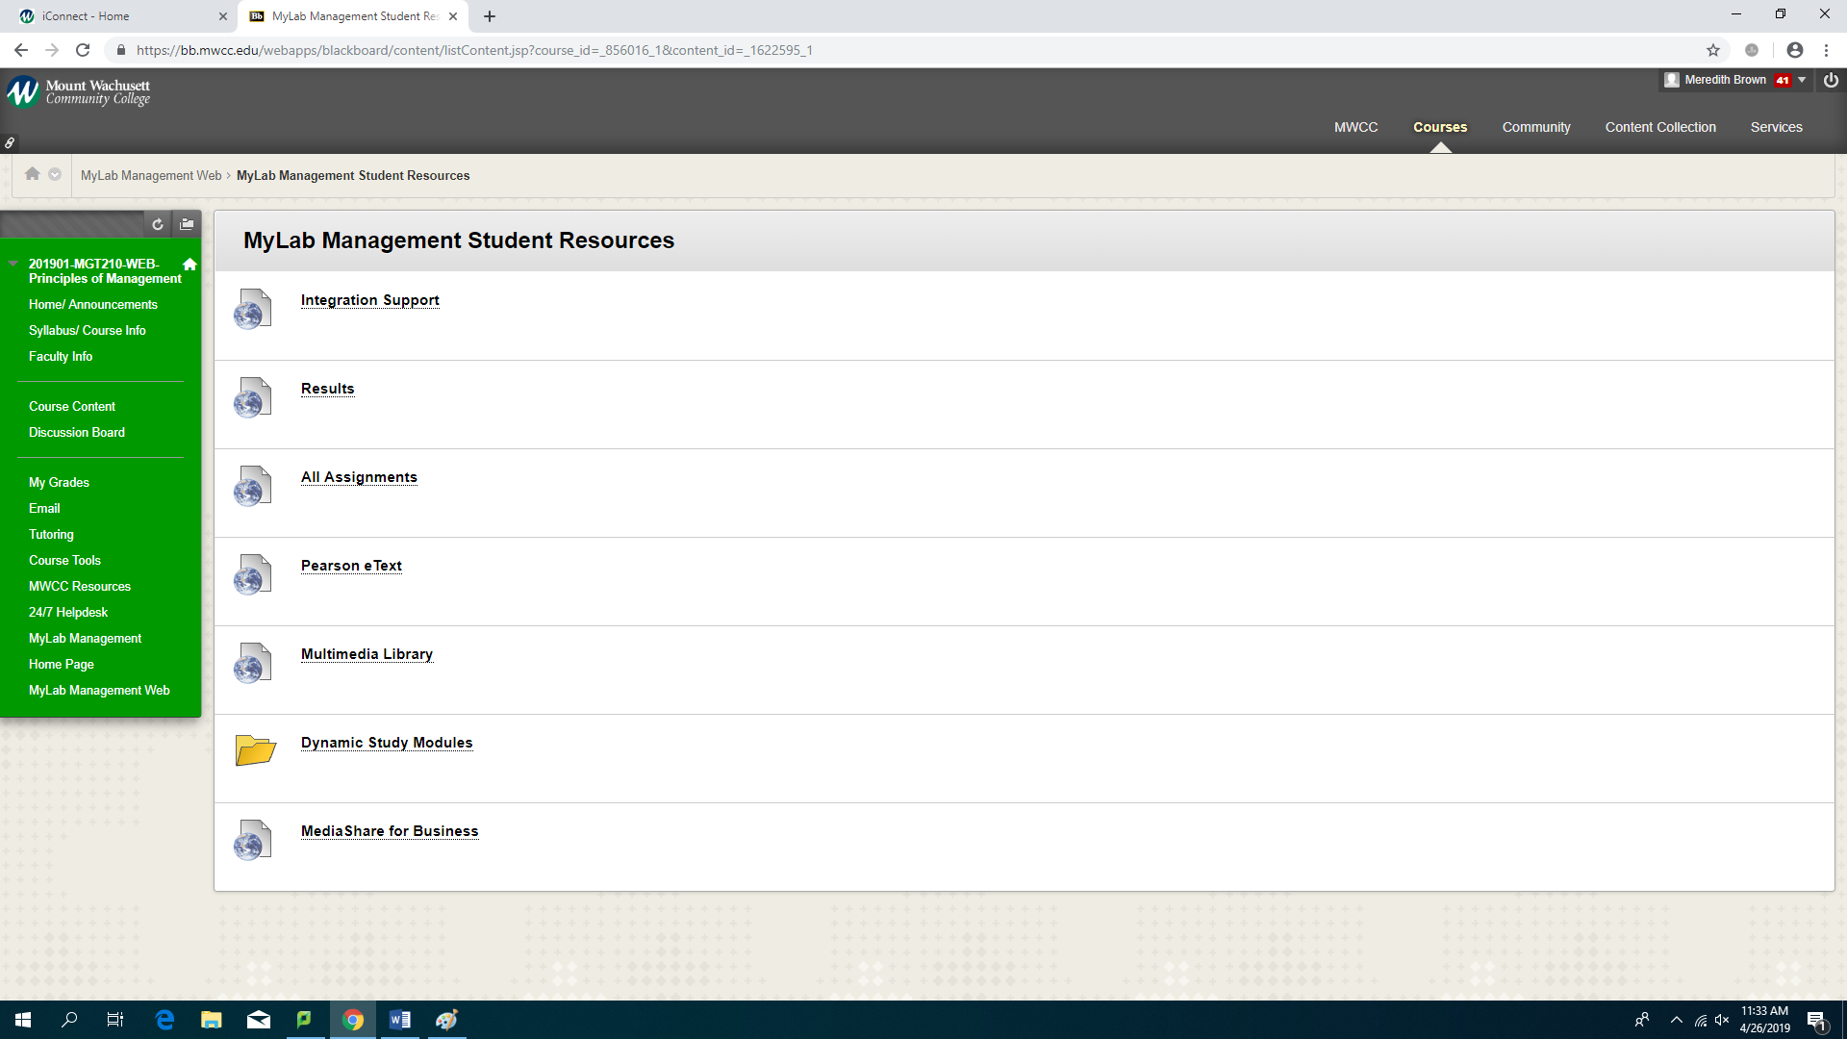
From there is will redirect you to the Pearson site. Unfortunately you can’t log in directly from the Pearson homepage because the link is specific to the course to allow students free access.
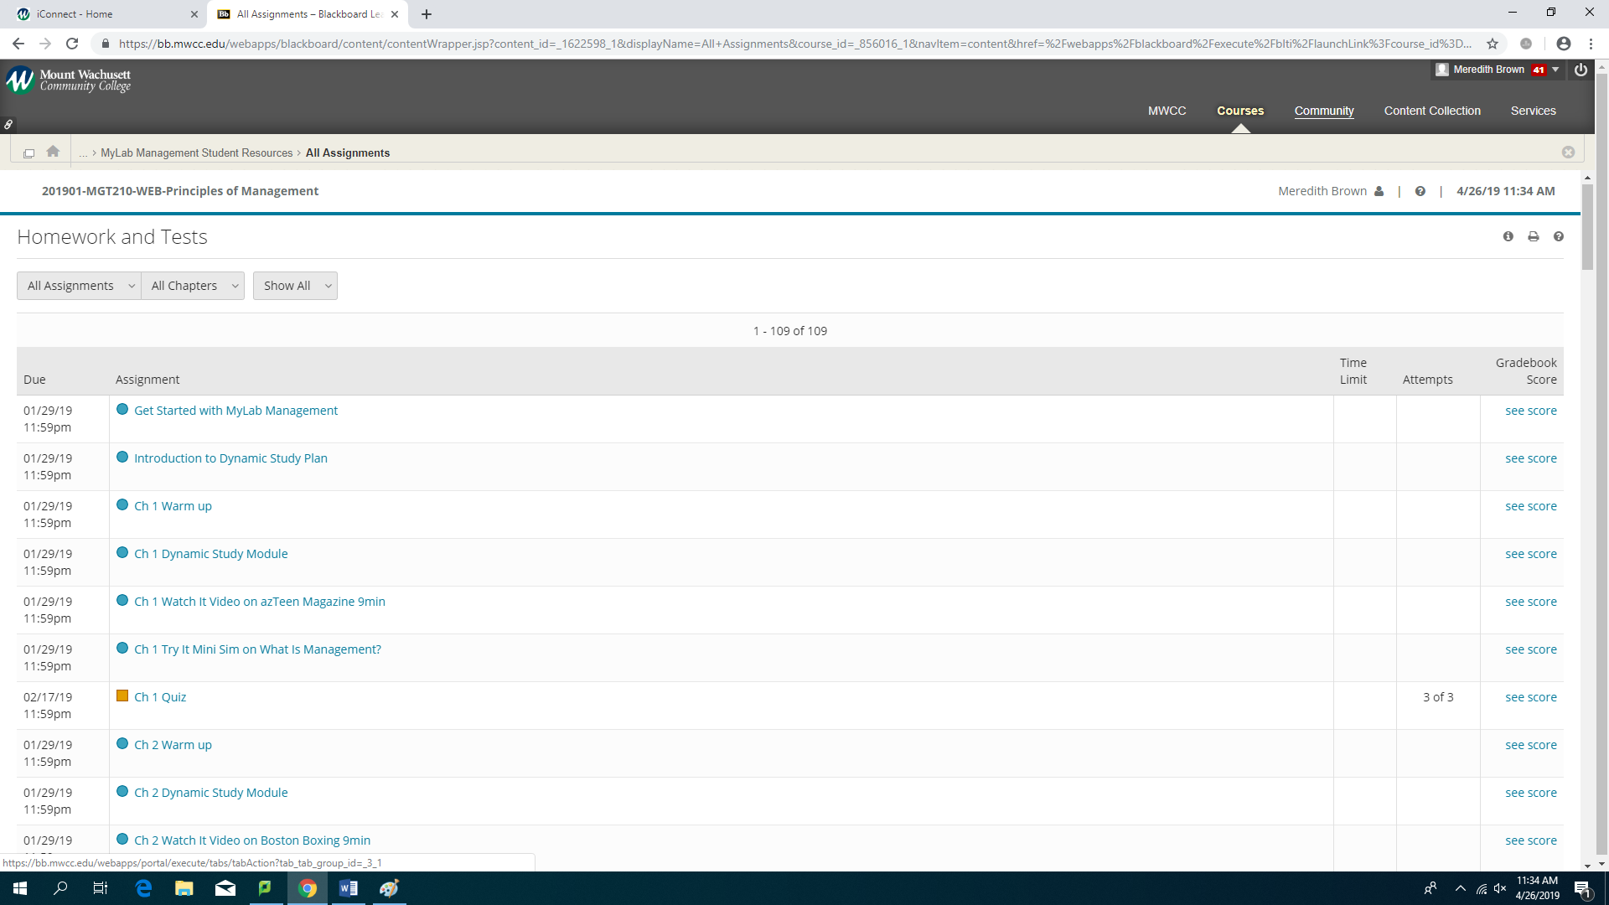
These are chapters 15 & 16;
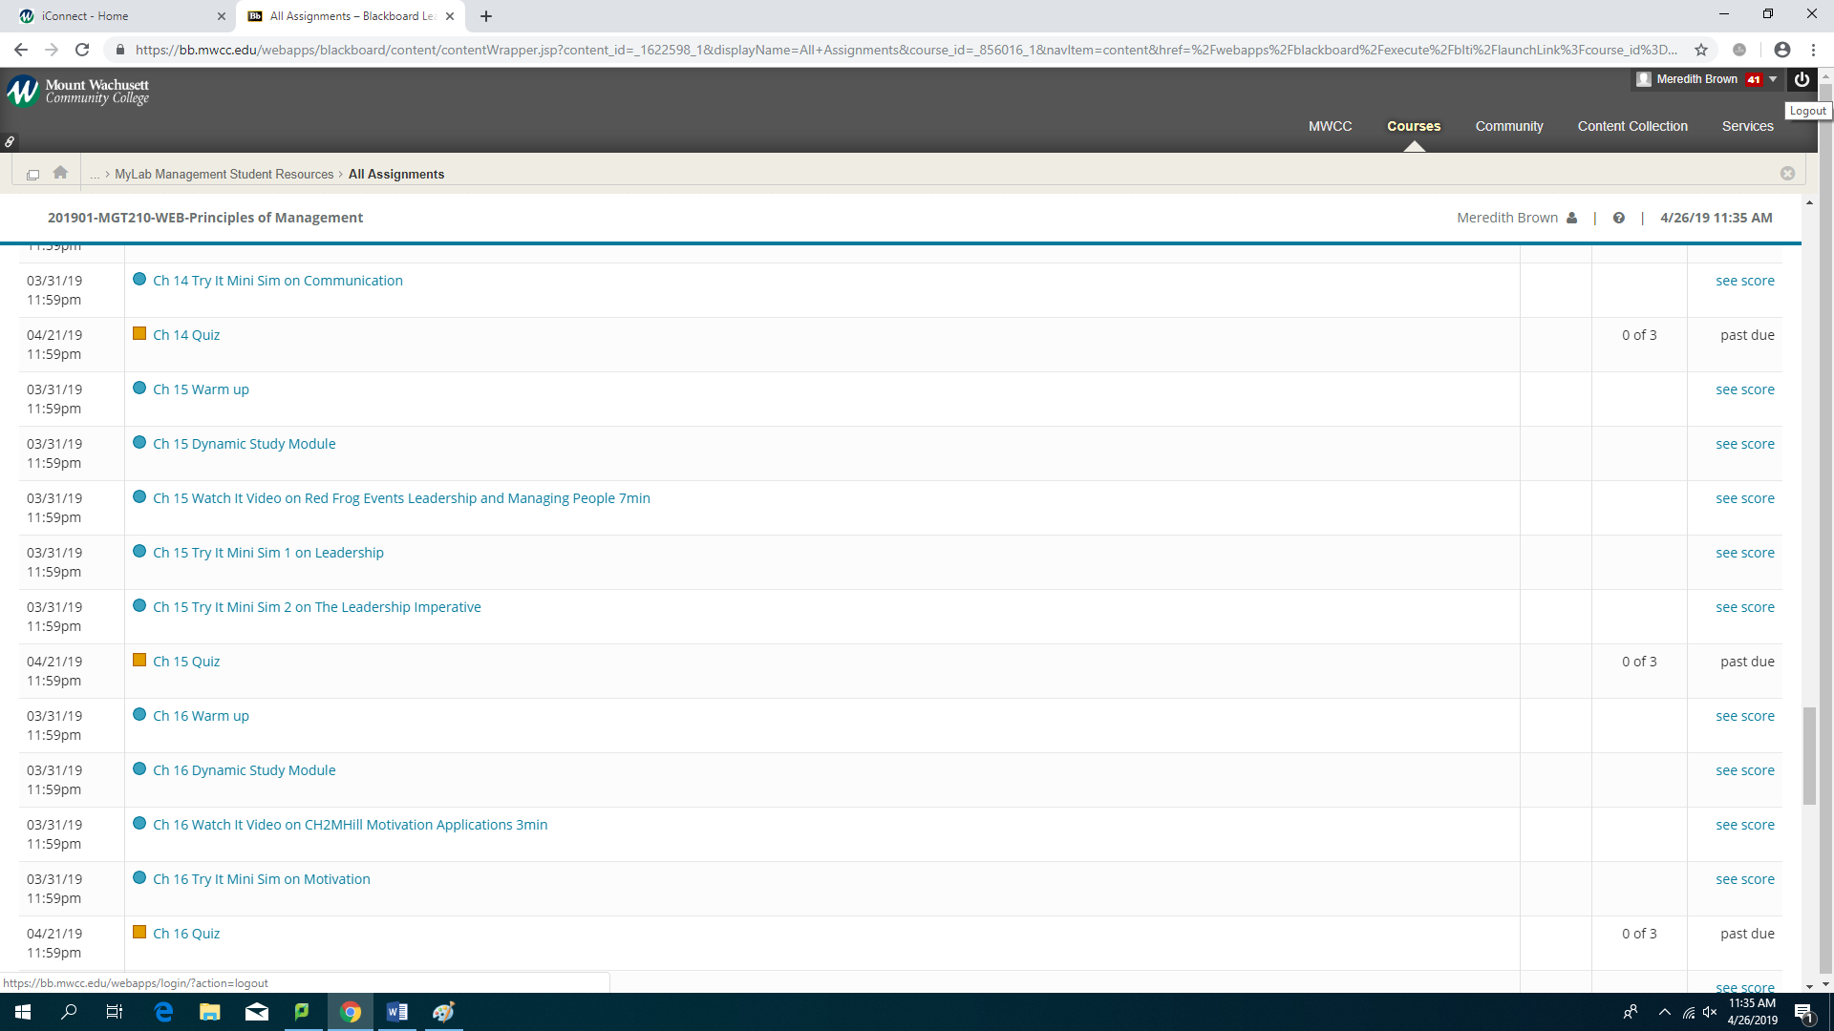
The highest scores you can get are 90% on all assignments other than the quiz the highest score you can get is 80%.

Thanks

